02. Matrix Print

- Print an M x N matrix.

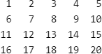

void print_matrix(int a[M][N])
{
for (int i = 0; i < M; ++i)
{
for (int j = 0; j < N; ++j)
{
printf("%d ", a[i][j]);
}
}
}

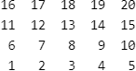

void print_matrix(int a[M][N])
{
for (int i = M-1; i >= 0; --i) // for (int i = 0; i < M; ++i)
{
for (int j = 0; j < N; ++j)
{
printf("%d ", a[i][j]); // a[M-i-1][j]
}
}
}

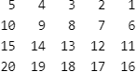

void print_matrix(int a[M][N])
{
for (int i = 0; i < M; ++i)
{
for (int j = N-1; j >= 0; --j) // for (int j = 0; j < N; ++j)
{
printf("%d ", a[i][j]); // a[i][N-j-1]
}
}
}

The following prints a matrix by 180 degrees clockwise.

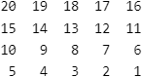

void print_matrix(int a[M][N])
{
for (int i = M-1; i >= 0; --i) // for (int i = 0; i < M; ++i)
{
for (int j = N-1; j >= 0; --j) // for (int j = 0; j < N; ++j)
{
printf("%d ", a[i][j]); // a[M-i-1][N-j-1]
}
}
}

- Rotation.

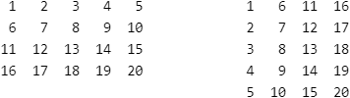

void print_matrix2(int a[M][N])
{
for (int j = 0; j < N; ++j)
{
for (int i = 0; i < M; ++i)
{
printf("%d ", a[i][j]); // b[j][i] = a[i][j]
}
}
}

Print an M x N matrix by 90 degrees clockwise.

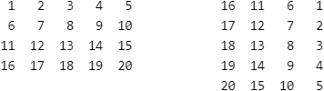

void print_matrix2(int a[M][N])
{
for (int j = 0; j < N; ++j)
{
for (int i = M-1; i >= 0; --i) // for (int i = 0; i < M; ++i)
{
printf("%d ", a[i][j]); // a[M-i-1][j]
}
}
}

Print an M x N matrix by 90 degrees counter clockwise.

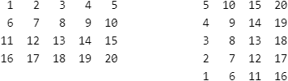

void print_matrix2(int a[M][N])
{
for (int j = N-1; j >= 0; --j) // for (int j = 0; j < N; ++j)
{
for (int i = 0; i < M; ++i)
{
printf("%d ", a[i][j]); // a[i][N-j-1]
}
}
}

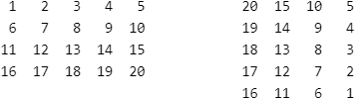

void print_matrix2(int a[M][N])
{
for (int j = N-1; j >= 0; --j) // for (int j = 0; j < N; ++j)
{
for (int i = M-1; i >= 0; --i) // for (int i = 0; i < M; ++i)
{
printf("%d ", a[i][j]); // a[M-i-1][N-j-1]
}
}
}

- Given an N x N matrix representing an image, rotate the image by 90 degrees clockwise.

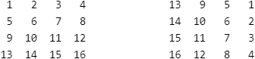

You can first print to a temporary matrix, and then copy back.

void rotate(int a[][N])
{
int b[N][N];

for (int j = 0; j < N; ++j)
{
for (int i = M-1; i >= 0; --i)
{
b[j][i] = a[i][j];
}
}

// copy b to a
}

The following shows how to use O(1) space.

void rotate(int *a[], int n)
{
for (int i = 0; i < n / 2; ++i)
{
for (int j = i; j < n - i - 1; ++j)
{
int temp = a[i][j];

a[i][j] = a[n - j - 1][i];
a[n - j - 1][i] = a[n - i - 1][n - j - 1];
a[n - i - 1][n - j - 1] = a[j][n - i - 1];
a[j][n - i - 1] = temp;
}
}
}

- Write the code to convert a matrix in the following way without using extra space.

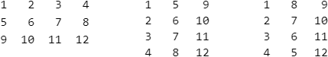

void print_matrix(int mat[M][N])
{
for (int j = 0; j < N; ++j)
{
for (int i = 0; i < M; ++i)
{
printf("%3d", i % 2 == 1 ? mat[i][N-j-1] : mat[i][j]);
}

printf("\n");
}
}

- Print a matrix in spiral way.

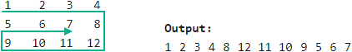

void print_spiral(int a[M][N], int m, int n)
{
int row = 0;
int col = 0;

while (row < m && col < n)
{
for (int i = col; i < n; ++i)
{
printf("%4d", a[row][i]);
}

++row;
if (row == m || col == n) break;

for (int i = row; i < m; ++i)
{
printf("%4d", a[i][n - 1]);
}

--n;
if (row == m || col == n) break;

for (int i = n - 1; i >= col; --i)
{
printf("%4d", a[m - 1][i]);
}

--m;
if (row == m || col == n) break;

for (int i = m - 1; i >= row; --i)
{
printf("%4d", a[i][col]);
}

++col;
}
}

- Given an M x N matrix, rotate all the elements one step in clockwise direction. (A single line is not rotated)

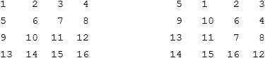

void rotate_matrix(int mat[M][N])
{
int m = M;
int n = N;

int row = 0;
int col = 0;

while (row < m-1 && col < n-1)
{
int temp = mat[row][col];

for (int i = row; i < m-1; ++i)
{
mat[i][col] = mat[i+1][col];
}
++col;

for (int i = col; i < n; ++i)
{
mat[m-1][i-1] = mat[m-1][i];
}
--m;

for (int i = m; i > row; --i)
{
mat[i][n-1] = mat[i-1][n-1];
}
--n;

for (int i = n; i > col; --i)
{
mat[row][i] = mat[row][i-1];
}

mat[row][col] = temp;
++row;
}
}

- Given an M x N matrix and a value k, rotate each ring of the matrix counterclockwise by k elements.

void spiral_rotate(int mat[M][N], int k)
{
int m = M;
int n = N;
int row = 0;
int col = 0;
int buffer[(M + N) * 2];

while (row < m - 1 && col < n - 1)
{
int index = 0;
for (int i = col; i < n; ++i)
{
buffer[index++] = mat[row][i];
}

for (int i = row+1; i < m; ++i)
{
buffer[index++] = mat[i][n-1];
}

for (int i = n-2; i >= col; --i)
{
buffer[index++] = mat[m-1][i];
}

for (int i = m-2; i > row; --i)
{
buffer[index++] = mat[i][col];
}

int r = k % index;
reverse(buffer, 0, r - 1); // left rorate
reverse(buffer, r, index - 1);
reverse(buffer, 0, index - 1);

index = 0;
for (int i = col; i < n; ++i)
{
mat[row][i] = buffer[index++];
}

for (int i = row+1; i < m; ++i)
{
mat[i][n-1] = buffer[index++];
}

for (int i = n-2; i >= col; --i)
{
mat[m-1][i] = buffer[index++];
}

for (int i = m-2; i > row; --i)
{
mat[i][col] = buffer[index++];
}

++row;
++col;
--m;
--n;
}
}

- Given an M x N matrix and a point (x, y). Print the matrix in a spiral form (clockwise) starting from the point.

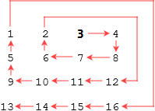

int row[] = { 0, 1, 0, -1 };
int col[] = { 1, 0, -1, 0 };

void printSpiral(int mat[M][N], int x, int y)
{
int direction = 0;
int count = 0;
int step = 1;

printf("%d ", mat[x][y]);
++count;

while (count < M * N)
{
for (int i = 0; i < step; ++i)
{
x = x + row[direction];
y = y + col[direction];

if (x >= 0 && x < M && y >= 0 && y < N)
{
printf("%d ", mat[x][y]);
++count;

if (count == M * N)
{
return;
}
}
}

direction = (direction + 1) % 4;

if (direction % 2 == 0)
{
++step;
}
}
}

- Given a positive integer N that represents dimensions of a 4N x 4N matrix with values from 1 to 4N x 4N filled from left to right and top to bottom. Form two coils from matrix and print the coils.

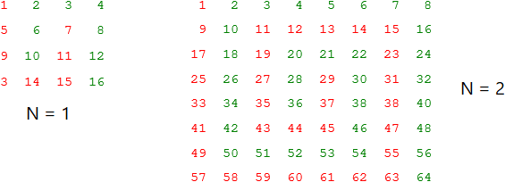

The first matrix prints:
10 6 2 3 4 8 12 16
7 11 15 14 13 9 5 1

The second matrix prints:
36 28 20 21 22 30 38 46 54 53 52 51 50 42 34 26 18 10 2 3 4 5 6 7 8 16 24 32 40 48 56 64
29 37 45 44 43 35 27 19 11 12 13 14 15 23 31 39 47 55 63 62 61 60 59 58 57 49 41 33 25 17 9 1

void printCoils(int n)
{
int len = n * n * 8; // number of elements in each coil

int coil1[len];
coil1[0] = n * n * 8 + n * 2;

int index = 1;
int step = 2;
int flag = 1;

while (index < len)
{
for (int i = 0; i < step && index < len; ++i)
{
coil1[index] = coil1[index - 1] - n * 4 * flag;
++index;
}

for (int i = 0; i < step && index < len; ++i)
{
coil1[index] = coil1[index - 1] + flag;
++index;
}

step += 2;
flag = -flag;
}

// print coil1

// print coil2; you don't have to create an array for coil2
for (int i = 0; i < n * n * 8; ++i)
{
cout << n * n * 16 + 1 - coil1[i] << " ";
}
}

- Print the matrix in snake pattern.

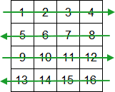

void print(int a[][N])
{
for (int i = 0; i < N; ++i)
{
if (i % 2 == 0)
{
for (int j = 0; j < N; ++j)
{
printf("%d ", a[i][j]);
}
}
else
{
for (int j = N - 1; j >= 0; --j)
{
printf("%d ", a[i][j]);
}
}
}
}

- Print a matrix in wave form.

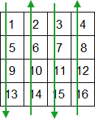

void print(int a[][N])
{
for (int j = 0; j < N; ++j)
{
if (j % 2 == 0)
{
for (int i = 0; i < N; ++i)
{
printf("%d ", a[i][j]);
}
}
else
{
for (int i = N - 1; i >= 0; --i)
{
printf("%d ", a[i][j]);
}
}
}
}

- Print a matrix diagonally.

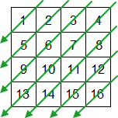

void print(int a[][N])
{
for (int i = 0; i < N; ++i)
{
for (int j = i; j >= 0; --j)
{
printf("%d ", a[i - j][j]);
}
}

for (int i = 1; i < N; ++i)
{
for (int j = N - 1; j >= i; --j)
{
printf("%d ", a[N - 1 – j + i][j]);
}
}
}

The following shows another solution which is easier to understand.

void print(int a[][N])
{
int row;
int col;

for (int i = 0; i < N; ++i)
{
row = 0;
col = i;

while (row < N && col >= 0)
{
printf("%d ", a[row][col]);
++row;
--col;
}
}

for (int i = 1; i < N; ++i)
{
row = i;
col = N - 1;

while (row < N && col >= 0)
{
printf("%d ", a[row][col]);
++row;
--col;
}
}
}

- Print the matrix in a zag-zag fashion.

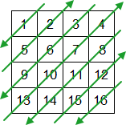

void print(int a[][N])
{
bool flag = true;

for (int i = 0; i < N; ++i)
{
if (flag)
{
for (int j = i; j >= 0; --j)
{
printf("%d ", a[i - j][j]);
}
}
else
{
for (int j = 0; j <= i; ++j)
{
printf("%d ", a[i - j][j]);
}
}

flag = !flag;
}

for (int i = 1; i < N; ++i)
{
if (flag)
{
for (int j = N - 1; j >= i; --j)
{
printf("%d ", a[N - 1 - j + i][j]);
}
}
else
{
for (int j = i; j < N; ++j)
{
printf("%d ", a[N - 1 - j + i][j]);
}
}

flag = !flag;
}
}

